Grand Canyon National Park
Teacher-Led Geology Lessons and Workbook

This teacher-led geology lesson is intended to help your students better engage with the Canyon in front of them. This program is designed such that the stations can be completed in any order; we recommend splitting your group into smaller pods and rotating through the stations. The final two pages of this document are the worksheet for students.
Essential Question: How can I observe and notice evidence of geologic change over time in the environment?
Grades: 4th, 7th, 8th
Arizona Science Standards: 4.E1U1.6, 4.E1U1.7, 7.E1U1.6, 8.E1U1.6, 8.E1U3.7
Materials: For each student, supply one double-sided worksheet, a pencil, and a surface to write against.
Location: Bus parking is available near the Visitor Center, at Park Headquarters, or at the Backcountry Office (not shown in below map). There is no bus access to the Yavapai Geology Museum parking area. The program takes place on the Rim Trail between the Village and the Visitor Center. Full South Rim map: Grand Canyon Pocket Map: South Rim Services Guide (nps.gov)

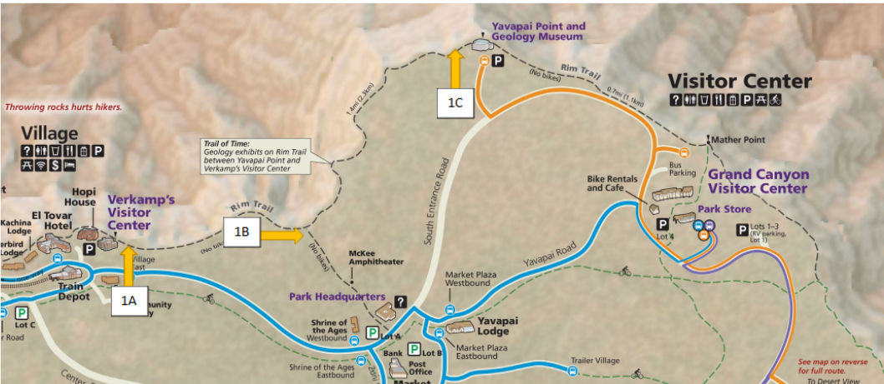

Station 1: Engage and Explore
Location: Stop 1A, 1B, or 1C as seen on map

Have students begin by looking at the canyon and asking them the following questions:
What do you see? What colors, patterns, shapes and other features? What do you wonder about? What does it remind you of?
Take students to the Trail of Time informational exhibit (3 location options: 1A, 1B, or 1C on map) where there is a model of stacked rocks. Read the text of the exhibit together, then ask students the same questions about the stacked rocks they see in front of them.
What do you see? What colors, patterns, shapes and other features? What do you wonder about? What does it remind you of?
Bonus: If there is extra time have students walk some of the Trail of Time, taking the million-year steps and observing the rocks. You can have them fill out the attached bonus observation sheet.
Station 2: Erosion Story and Play
Location: Along rim trail between Visitor Center and Village

Gather the students either in an open space off trail. Have them choose a sound for the following words:
- Rocks
- River
- Layer
- Erosion, Eroding, Erode
- Weathering
Read the following story as students respond to the highlighted words with the group chosen sounds. Do a practice sentence first if needed.
Hundreds of millions of years ago, layers of rock began to form in the area we now call Grand Canyon. Layer upon layer, rock stacked on top of each other preserving the remains of ancient oceans, ancient deserts and ancient swamps.
Then, powerful forces inside the Earth caused the Earth’s tectonic plate to collide, lifting the rock layers thousands of feet into the air. The layers now towered over 7,000 feet above sea level, a high and vast plateau had been formed. Known as the great Colorado Plateau, this land of colorful rock was now high above the surrounding landscape.
With the land now high above sea level, new powerful forces began tearing the rock layers apart, some pure forces of destruction! Power! Strength! These forces of destruction are known as weathering and erosion; simple names for forces that can destroy solid rock. Each force plays a critical role, weathering breaks rock apart into smaller pieces and erosion moves the broken pieces to new places, sometimes transporting them hundreds or thousands of miles. An easy way to remember it: Weathering breaks it; erosion takes it!
Water, that substance that keeps us alive, is the main destructive energy behind weathering and erosion; rain, snow, ice, rivers and streams all work to tear the rock apart and transport it. Water gets help from wind, gravity and the roots of plants, which can squeeze into cracks and force rock apart.
The biggest source of water at work carving Grand Canyon is the mighty Colorado River.
Six million years ago, the river began carving its way deep into the rocks of the Colorado Plateau, like a knife cutting through a layer cake, revealing rock layers the color of chocolate, vanilla, pistachio, mango, red velvet, eventually creating a canyon one mile deep, 10 miles wide and 277 miles long; a massive gash in the Earth’s crust!
These powerful forces are still at work today breaking down the rock and transporting them down stream. What do you think it will look like in another million years?

Bonus: Read the story again, but this time have students form groups and act out these parts:
- Canyon walls
- Wind
- Rain
- River
Finally, read the story again and have students act the parts and do the sounds (teacher will need to assess if this will be helpful or chaotic for their students).
Station 3: Trail of Time Rock Observation
Location: Along rim trail between Yavapai Geology Museum and Village

Have students walk some of the Trail of Time, taking the million-year steps and observing the rocks. Have students fill out the Trail of Time observation page.
Bonus – Weathering and Erosion Photo Project:
If students have smart phones accessible, have them take at least 3 pictures with examples of weathering and erosion as they walk the Trail of Time. After the walk, have them share the pictures with the class.
Station 4: Journaling
Location: Along rim trail between Visitor Center and Village

Station 4 is flexible; some students may need time to just sit and enjoy the canyon. Other students may want something more structured. This is up to the teacher to decide what they feel their students need.
Students will have 15-20 minutes to either draw, write a story, write a poem, etc. for the following prompt:
You are a rock perched at the edge of Grand Canyon. What do you see? How do you feel?
Name:
Trail of Time Rock Observation
As you walk through the trail of time, take some observations about the rocks you find.
Drawing of Rock | Name | Color | Texture/Pattern | Time formed

Journaling
Draw, write a story, write a poem, etc. for the following prompt:
You are a rock perched at the edge of Grand Canyon. What do you see? How do you feel?

